
April 2008 Volume II, No. 2
Among Friends

 | have not yet explored.  Since our last newsletter, the Friends of the Squirrel Hill Library have used some of the money from our book sales and memberships to enhance those resources:  1. The new computer chairs have arrived! (See Holly's column on page 6.) They should make sitting at the work stations more comfortable for everyone.  2. The library received a large number of classical CD's and had no space for them. So - your FOL dues to the rescue - we bought two more gondolas (shelf units) to handle them for you to enjoy.  You can also purchase a library book in honor of a friend or loved one. Ask at the circulation desk to arrange a donation.  See you at our Annual Meeting in June!
  
  Anyone who has never
  made a mistake
  has never tried
  anything new.
  Albert Einstein
  1879-1955
  WELCOME,
  NEW MEMBERS
  Jaclyn Barnes
  Maren Cooke
  Kathleen Jakub
  Mathiew Lebiere
  Jo Recht
  Yetta Samuels
  Barbara Shore
  Jeff Tzucker
  PRESIDENT’S MESSAGE  by  Marion Damick  While I’m writing this in March when it’s chilly and raining, I’m hoping that next month it really will be Spring, and we all can be outside enjoying the lovely weather -- when we're not inside reading a good book or in the library taking advantage of some of the resources that we | 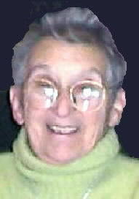
  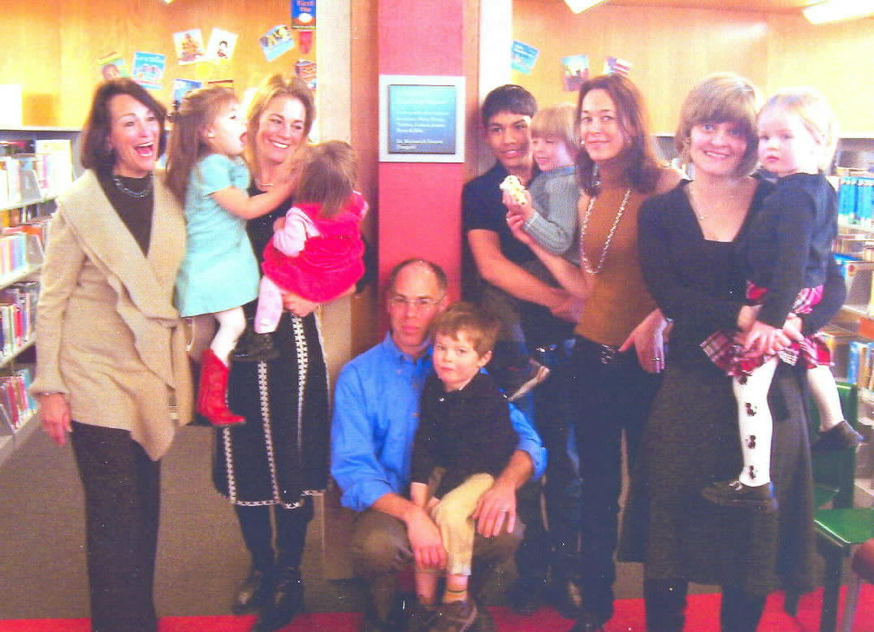 | A very pleasant event occurred in the children's section on February 3, 2008. There was a dedication of a plaque commemorating a donation from the Finegold family in honor of their grandchildren. This is a particularly lovely thing to do in memory of a loved one and we all appreciate Marian Finegold (at left in the picture) and her family for this donation.
 |  | Join us also at  our regular  Friends  Meetings:  Saturdays  at 10 a.m:  April 5  and  May 3
  Annual Meeting and Special Program
  Sunday, June 1 from 1:30 to 3 p.m.
  After a brief business meeting and election of officers, the Friends of the Squirrel Hill Library will present Penny Layne from "PAWS WITH A CAUSE".
   | This organization trains assistance dogs for people with disabilities.  Penny will have a trained dog with her to show us how they work.  We will then have refreshments and a social time. Everyone is invited. | 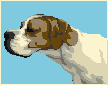

Published by the Friends of the Squirrel Hill Library
5801 Forbes Avenue Pittsburgh, PA 15217
website: www.clpgh.org/locations/squirrelhill e-mail: Friends@pittsburghusedbooks.com
editing: Joan Schwartzman production: Margie Spenser, Marion Damick, Serena Spenser mailing list: Margie Spenser

April 2008 Among Friends Volume II, No. 2
April 2008 Among Friends Volume II, No. 2

  Art at the  Squirrel Hill Library  ----------------------------------------------------------  Coming up are:  April: Yury Mudranko  mixed media  May: Special Artists  varied media  June: Jeanne Bergad  portraits | While we here in the children's department have enjoyed reading lots of stories about snow this winter, we are looking forward to sunshine and warmer weather. A great book for "thinking spring" is Up, Down, and Around, this year's choice for Pennsylvania's "One Book, Every Young Child" program. Pittsburgh's own Katherine Ayres wrote this wonderful book in which a garden produces a variety of edible plants, such as corn that grows up, onions that grow down, and tomato vines that twine all around. This statewide collaborative program highlights the importance of early literacy for preschoolers. The Squirrel Hill library will be holding special storytime programs to highlight this book on Monday, April 14 at 6:00 p.m. and Saturday, April 19 at 11:00 a.m.  The staff of the Children’s Department is also busy preparing for this year’s  In children's literature news, the 2008 Newbery and Caldecott award winners were announced in January. The 2008 Newbery Medal winner is Good Masters! Sweet Ladies! Voices From a Medieval Village by Laura Schlitz. The Caldecott Medal was awarded to The Invention of Hugo Cabret by Brian Selznick. To read more about these titles and awards visit the American Library Association's website at:  http://www.ala.org/ala/alsc/awardsscholarships/  literaryawds/2008MediaAwardWinners.htm.  The Sydney Taylor Book Awards were also awarded earlier this year. These awards are given by The Association of Jewish Libraries. The 2008 winners are: The Bedtime Sh'ma: A Good Night Book by Sarah Gershman (for younger readers), The Entertainer and the Dybbuk by Sid Fleischman (for older readers), and Strange Relations by Sonia Levitin (for teens). On a special note, Penina Levine is a Hard-Boiled Egg by CLP's own Rebecca O'Connell was named a Notable Book for Older Readers! Visit the website at:  http://www.jewishlibraries.org/ajlweb/awards/st_books.htm  Stop by or call the library to reserve a copy of these great award-winning books!  A pessimist sees the difficulty in every opportunity;  an optimist sees the opportunity in every difficulty.  Winston Churchill  1874-1965
  Children’s Room Happenings | by Erin Scioli  Children's Library Assistant | 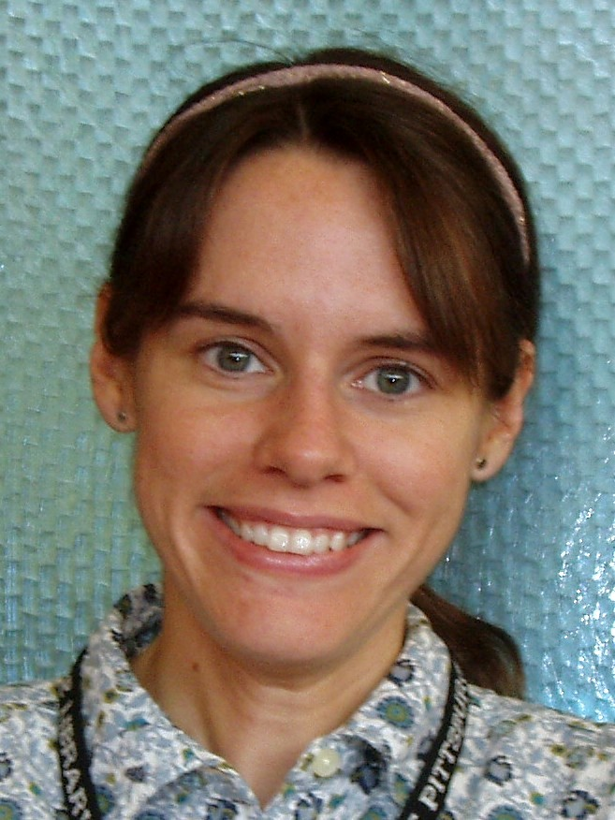
  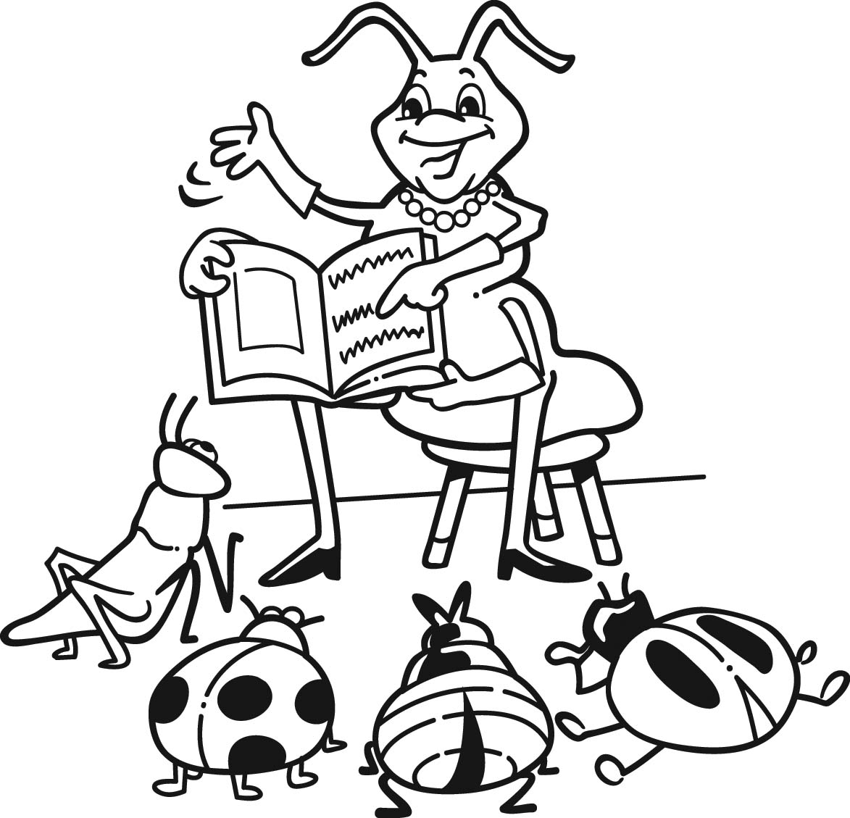 | summer reading club. The 2008 theme is “Catch the Reading Bug.” Sign up for summer reading beginning Sunday, June 8 at the Summer Reading Extravaganza held from noon to 5 p.m. outside the main library in Oakland, or come into Squirrel Hill or any Carnegie Library of Pittsburgh after June 8 to get your folder and start your summer reading!
SPECIAL ARTISTS
ON EXHIBIT
We are as excited as the artists who will be exhibiting their work during the month of May. They are adults with mental/physical disabilities, receiving therapy and help at Milestone (formerly Allegheny East). Milestone is located on South Avenue in Wilkinsburg and offers all types of activities. The work will be using a variety of media and should be exciting to view. As with all Art at the Squirrel Hill Library, the work is available for purchase. Contact
Jennifer Macioce,
412-473-8059

Our schedule for artists is full through this November. If you are interested in exhibiting after that, contact
Marion Damick,
412-521-3075.

2

April 2008 Among Friends Volume II, No. 2

Friends' Corner  Reflections About Carnegie Libraries  By Shirley T. Shratter  As I was growing up in Duquesne, one of the best things about my summer vacations was going to the library and bringing home books to read.  Today my impressions are much the same. I am a co-leader with Sheila Solow of a book club called “WIN” (Women in Network). We have 21 members and meet often in a private and quiet room in the Squirrel Hill Library. A book of historical fiction or autobiography  Everyone in the group found it fascinating.  My husband Morry and I are co-producers of a program called  “More Than Just Learning” on public access TV and we invited some members of the book club to join us for a discussion of this book. The interaction was very stimulating. The program will air in Pittsburgh every Thursday in April at 10 PM on cable channel 21. It is also available on www.pctv21.org. | Amazing Facts  about Public Libraries  in Allegheny County  - There are 45 ACLA libraries with 87 locations plus bookmobile stops  - Your one free card is good at any library  - You can order and reserve materials and return anything you borrow at any library  - You can borrow videos and DVDs at no charge  - All ACLA libraries have FREE public computers with high-speed internet access and popular programs like Word and Excel  - You can access the holdings of ACLA libraries online from any computer at http://catalog.einetwork.net  - All ACLA libraries offer programs and special events for people of all ages and interests, and most are FREE  Think about it.  Is this wild, or what?? 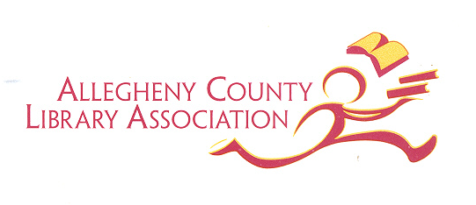
  is chosen by consensus of the members. We select a book which is almost always available and in great supply.  Our most recent book was “Out of the Furnace” by Thomas Bell. This book is about the history of our area: immigration, steel mills, unions and the Carnegie Library. | 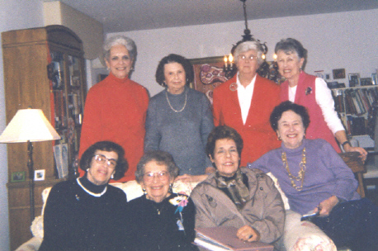  from left: front - Barbara Andelman, Fay Weissberg,  Marilyn Ashkin, Shirley Shratter. Back - Sheila  Solow, Sylvia Sussna, Carol Manes, Barbara Coffey.

Age is strictly a case of mind over matter. If you don’t mind it doesn’t matter.
Jack Benny 1894-1974

 |  | Film, Fiction and Fun  The Film, Fiction, and Fun program series continues to explore the relationship between classic novels and the films they inspired. Meetings are held on the last Thursday of each month.
April 17th 1-4 PM Wuthering Heights by Emily Bronte  May 16th 1-4 PM Hamlet by William Shakespeare  June 19th 1-4 PM Ship of Fools by Katherine Ann Porter  Participants are encouraged to read the novel, then join us for a screening of the film and a discussion led by CCAC's Jeanne Bergad. | 

3

April 2008 Among Friends Volume II, No. 2

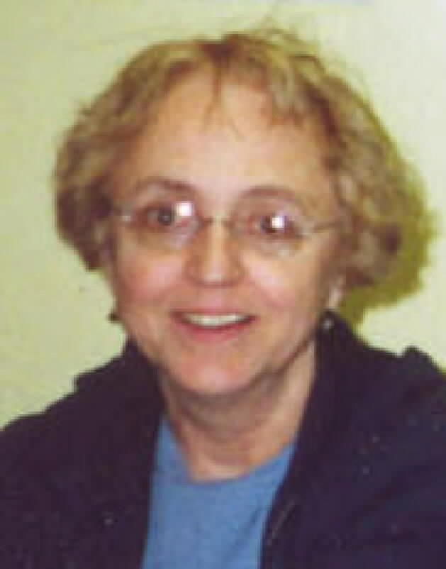  by Pat Bender, mini-sale chair | MINI SALE NEWS  Our mini-sale in recognition of Black History Month was well received and earned approximately $200. In addition, Sala Udin, former member of City Council, came by on Sunday to buy books and thank us for our efforts. Next year, our February sale will have a broader scope and will be called American History - Red, white and Black. I am  already collecting books for this sale.  March featured Home Arts and Hobbies and Gardening plus a large selection of cookbooks. There was also a selection of books from "Memory Lane" - editions of  favorites from days gone by. Sales were brisk and FOL earned $650.
The Friends of the Library Boutique draws more interest each time with new offerings. It will be open at all
the FOL Book Sales.
Sincere and heartfelt thanks must go to those members of FOL who have contributed their time and support
to the mini-sales.
Donations of all books and discarded jewelry and craft items are always needed. Yarn of any kind is also
needed for a fall project.

BOOKS, BOOKS, BOOKS, BOOKS, BOOKS, BOOKS, BOOKS,  This year we will celebrate the 50th anniversary of National Library Week. From April 13th to 19th the Friends of the Library will have membership tables set up at both entrances, with lots of posters and handouts about libraries and reading. Our Spring Cleanup book sale will be held concurrently. Anybody who joins the Friends then will get 50% off of the first $10 they spend on books.  Getting ready for the celebration, I've been looking at books and websites about libraries and reading. I'm amazed anew at what a fantastic idea libraries turned out to be. First libraries, then lending |  | 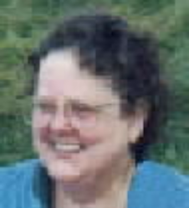  by Margie Spenser  Book Sale Committee
libraries, then PUBLIC libraries, free to EVERYBODY! Think about it. What a concept! What a miracle!

August Wilson, the great playwright from Pittsburgh, dropped out of school when a high school teacher accused him of plagiarism (after all, what young black boy could possibly write that well!?!) and he educated himself at the Carnegie Library. I read somewhere that the library gave him a graduation certificate – I'd sure like to know more about that. Maybe I should ask a librarian. If anybody would know where to find out more, a librarian would.

Before books were mass produced, a library of any size indicated great wealth. Access to them was possible only if you knew the right people, or had taken holy orders. Once Gutenberg invented the printing press, books started getting cheaper and more people learned to read them – and to want more and more of them.

Before there were public libraries, there were lending libraries. These were places where you could "rent" a book, so they were still restricted to people with comfortable incomes. Some were "subscription" libraries; you had to buy a share in them. In 1731, Benjamin Franklin and some of his fellow printers started the first subscription library in the colonies. It was not free to the public – it could only be used by contributors -- but it inspired many imitators.

As this country came to believe in free public education to prepare everyone to participate in our burgeoning republic, so we began to see that we needed public libraries. The first tax-supported free library was opened in Peterborough, NH in 1833. Philanthropist Andrew Carnegie was not the first person to advocate that libraries should be "free to the people", but between 1886 and 1917 he gave so many towns the money to build them that "Carnegie" almost seems synonymous with "Public" or "Free".

Carnegie built 2,811 free libraries in all.* Of these, 1,946 were in the United States -- 59 in Pennsylvania. The very first Carnegie Library built in this country is only 13 minutes from Forbes & Murray, in Braddock. It is still in use as a library and community center. Take the Parkway East to the Edgewood/Swissvale exit. At the end of the ramp, follow signs to Braddock Avenue. Turn right and take Braddock Avenue all the way to Braddock; turn left onto Library Street. There is a great photo at http://en.wikipedia.org/wiki/ Image:BraddockPaCL.JPG. Many, many other facts about Andrew Carnegie's libraries are to be found at
http://andrewcarnegie.tripod.com/cfl.html

Come to our library during National Library Week and learn more about these amazing places!

A classic is a book that has never finished saying what it has to say.
Italo Calvino 1923-1985
4
*every source I consult gives a different number

April 2008 Among Friends Volume II, No. 2
 | All programs are scheduled for Wednesday  from 10:15 AM-11:00 AM  unless otherwise noted  Wednesday, April 23  from 10:15 to 1:00 PM  Please note: This program  is at a different time!  How to buy and sell on eBay with confidence and ease.  By  Nancy Cheskey, Small Business Specialist, U.S. Postal Service  Thursday, April 24  Special program on Thursday  Learn about how the U.S. Postal Service can help small businesses  expedite their deliveries, create & send direct mail and offer free  eco-friendly packaging and delivery.  By  Nancy Cheskey, Small Business Specialist, U.S. Post Office  Wednesday, April 30  Don't waste time and money any more on clutter.  Master the keys to getting organized!  By  Jody Adams, President, In Its Place  Wednesday, May 14  Find out how to use your minority and/or female status  to your advantage in developing a new business.  By  Christina Jumba, Director, Diversity Business Resource Center  Wednesday, June 11  Learn about the pay-per-click advertising that will  get customers to your website.  By  Traci Scharf, Analyst, Lunametrics
  NAMM BUSINESS CENTER PROGRAMS  April - June 2008  by Dorothy Kabakeris,  Namm Business Center Librarian | 
  Congratulations  to Liz Hughes, winner of  the March 16thdrawing  for the awesome  hand-crocheted afghan.  We sold 153 tickets.  Our thanks to the  anonymous crocheter. | 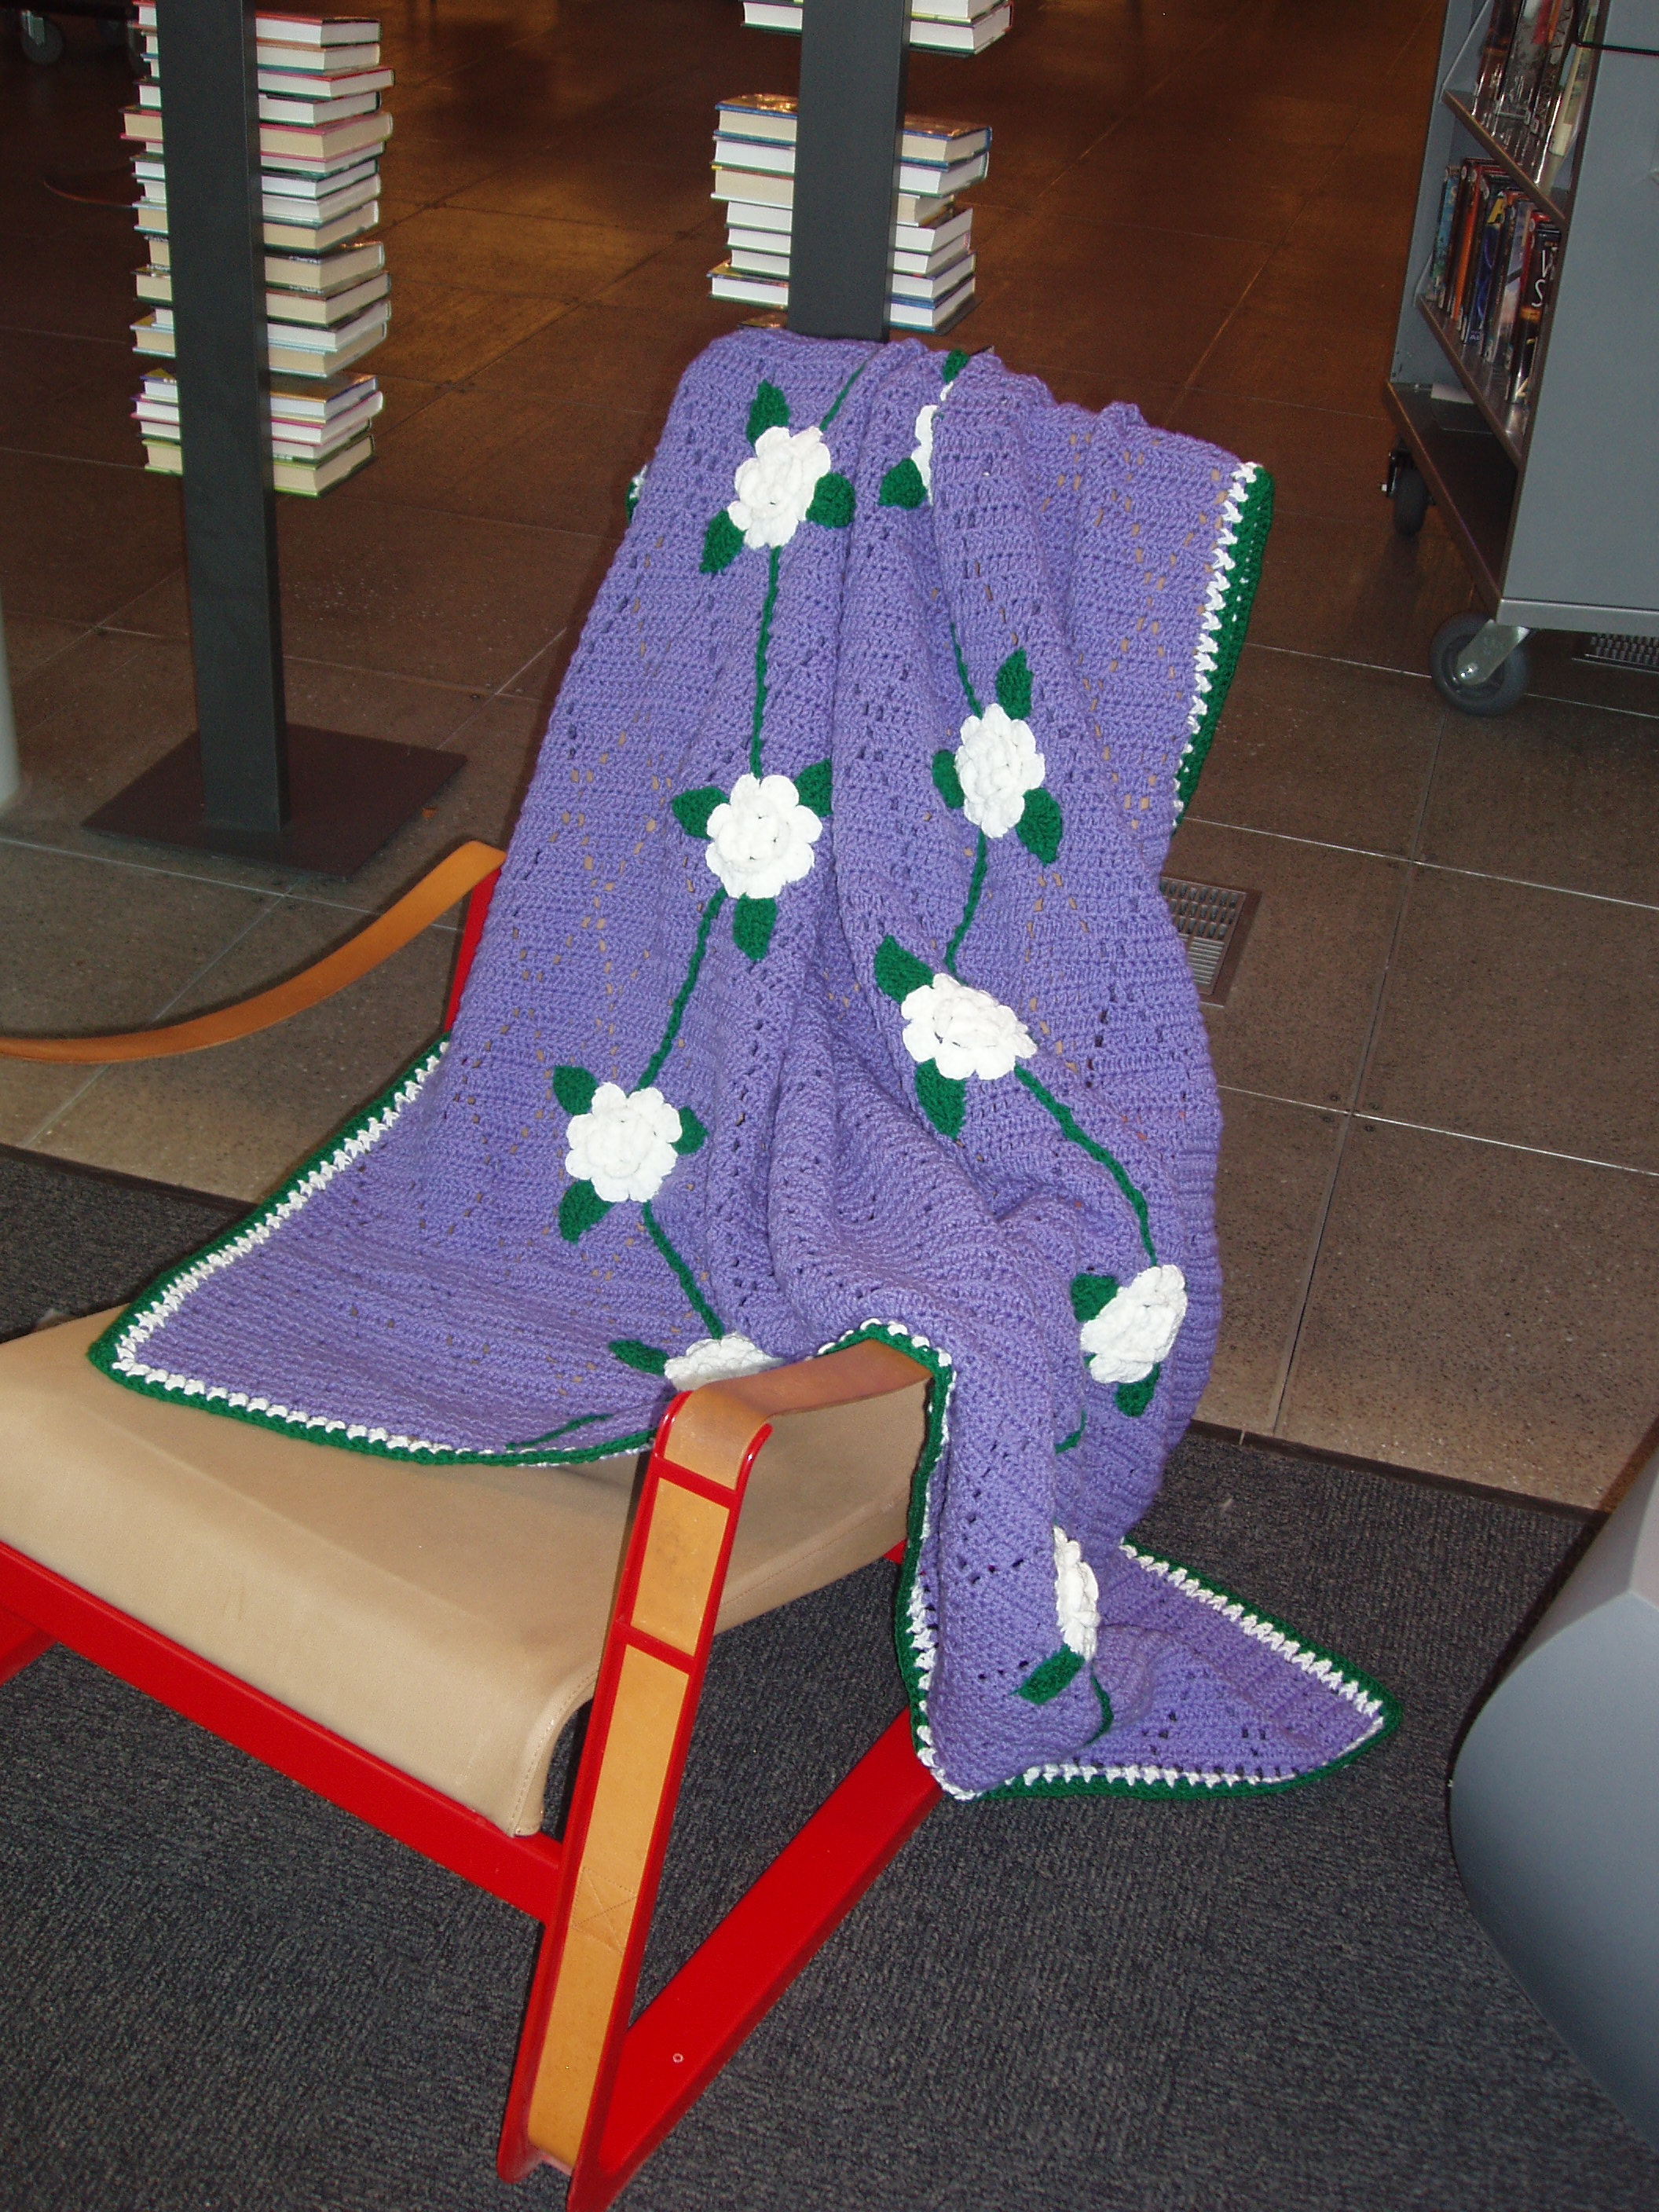
The Squirrel Hill
Adult Book Discussion Group
meets on the last Thursday
of the month from
1:00 PM to 2:00 PM.

All are Welcome.

April 24
Love and Louis XIV: the women in the life of the Sun King
by
Antonia Fraser, 2006

May 22
Water For Elephants
(a novel)
by Sara Gruen, 2006

June 26
The Judgment of Paris: the revolutionary decade that gave the world Impressionism
by Ross King, 2006

There are books of which
the backs and covers
are by far the best parts.
Charles Dickens
1812-1870

The monthly Namm newsletter lists our business programs, highlights a key business database each month, and offers a compilation of new business titles. If you are interested
in receiving it, email us at: squirrelhill@ carnegielibrary.org.
5

April 2008 Among Friends Volume II, No. 2
Adventures in Improving  Our Library  I want to give the wider Friends membership a little glimpse into the way that continual improvement works at the library, and the Friends' role in this process.  One of the repeated concerns we’ve heard since the branch was renovated has been about the uncomfortable match between the height of the keyboards at the public computer stations and the height of the chairs. Our users come in every shape, size, and configuration; satisfying the individual needs of all of our citizens can be a very difficult task. Finding a solution to the computer chair problem was a great example of this difficulty. | published in 1921. The verse is as follows:  “Life is not a highway strewn with flowers,  Still it holds a goodly share of bliss,  When the sun gives way to April showers,  Here’s a thought that we should never miss…”  The song tells us a sentiment that still holds true today. The thought is that no matter what happens in April, everything will be alright in May. This time of year can bring happiness and new beginnings to us all.  Let us know about your new beginnings. Write us at FOL, Squirrel Hill Library, 5801 Forbes Ave, 15217 or e-mail us at friends@pittsburghusedbooks.com.
  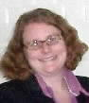 | Listening And Responding With A Lot Of Help From Our Friends!  By Holly McCullough, Manager,  Carnegie Library of Pittsburgh –  Squirrel Hill
  From the Editor  by Joan Schwartzman  Al Jolson sang a song called “April Showers” (music by Louis Silvers, words by B.G. DeSylva) that was | 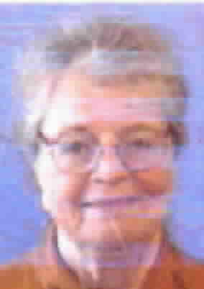
The adult and teen public computer stations were all built to be at an accessible height for a wheelchair, so that everyone would have the same access. Unfortunately this left us in a quandary about our chairs. If we put tall chairs at the stations, many people would be left with legs swinging. We considered keyboard trays to lower the keyboards but the trays often do not work well and get in people’s way. The Friends of the Library, who had also noticed the problem, suggested cushions for the seats. We considered this, but they would have needed frequent cleaning and still might not have given users enough individual adjustability and comfort.  I asked the Friends to purchase adjustable chairs for the stations so that each user could find what worked best for him or her. As always the Friends generously agreed to donate the money we needed. We brought in 5 sample chairs and allowed customers to try them out at the workstations, comment on them and vote on their favorites. Not surprisingly, given the diversity of our users, the votes were fairly evenly split amongst the chairs.  At the next Friends meeting, everybody tried the chairs and all voted for the same one! Forty of the selected chairs have been purchased and placed at the computers. We’ve had lots of positive reactions to the chairs already, with 2 enquiries about where we had purchased them within three days of their arrival! One overheard comment from a couple of teens as they entered the building: “COOL! NEW CHAIRS!” | I don’t imagine that these chairs will satisfy everyone. I know, for example, that some would prefer wheels. We opted out of wheels so that the chairs would be more stable for those needing to use the arms to get in and out.  I welcome hearing more comments and suggestions. We continually strive to get better and we can only do that through feedback from you. Please know that even if we don’t make immediate changes, as in this case we are taking in all of the feedback we get and working hard to balance everyone’s needs, the mission of the library, and our available resources.  Thanks to the Friends for helping again and again with raising the funds to help make this and other improvements happen.
   | 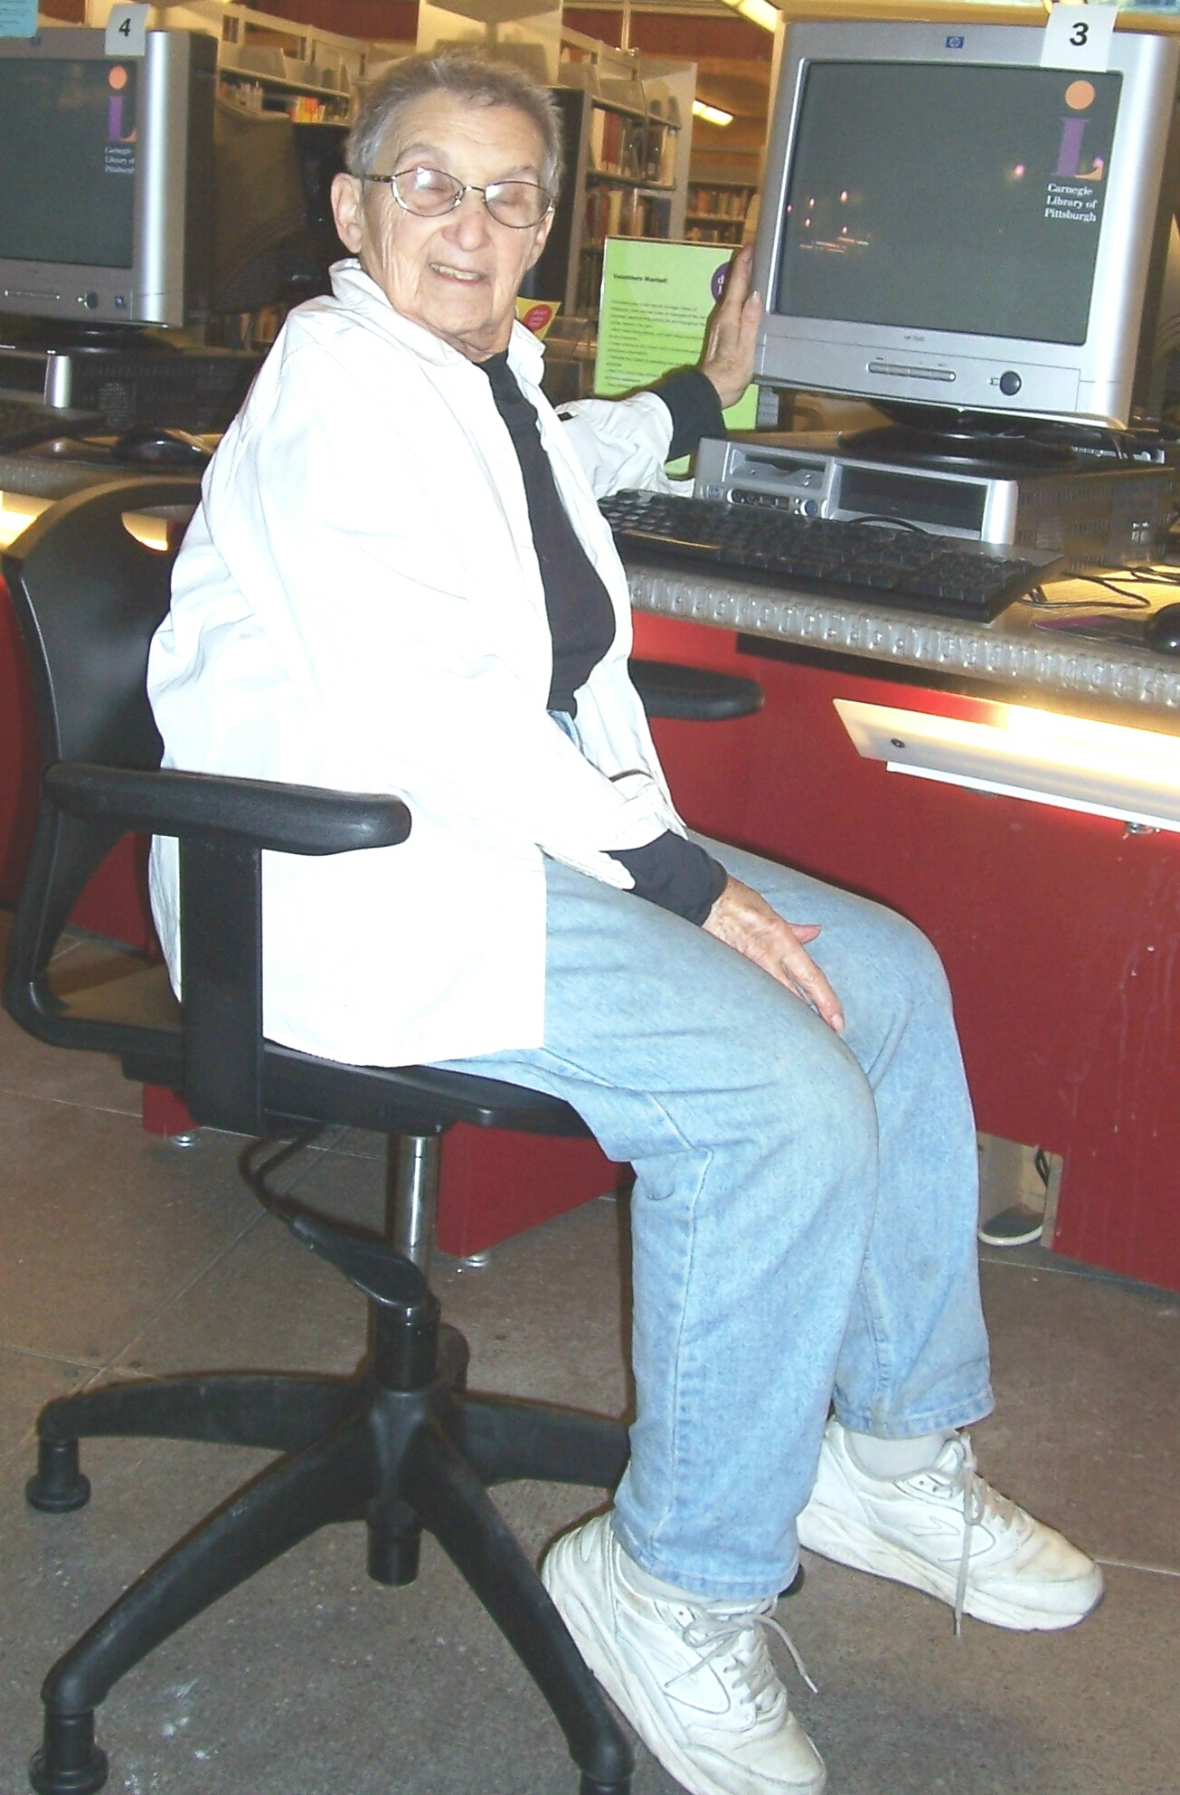 | Friends President Marion Damick looks as if her feet won’t reach the floor.  All she has to do is to reach her right hand down to a lever that will allow her to choose the ergonomically perfect height for her chair.

Carpe diem! Rejoice while you are alive, enjoy the day, live life to the fullest,
make the most of what you have. It is later than you think. Horace 65BC-8BC

6

April 2008 Among Friends Volume II, No. 2

Friends Officers  Marion Damick President  Joan Schwartzman Vice President  Eleanor Hershberg Treasurer  Margie Spenser Secretary  write us at  friends@pittsburghusedbooks.com | SPRING CLEANUP  BOOK SALE  to celebrate  the 50th anniversary of  National Library Week  Sun April 13th thru Sat April 19th  during library hours
  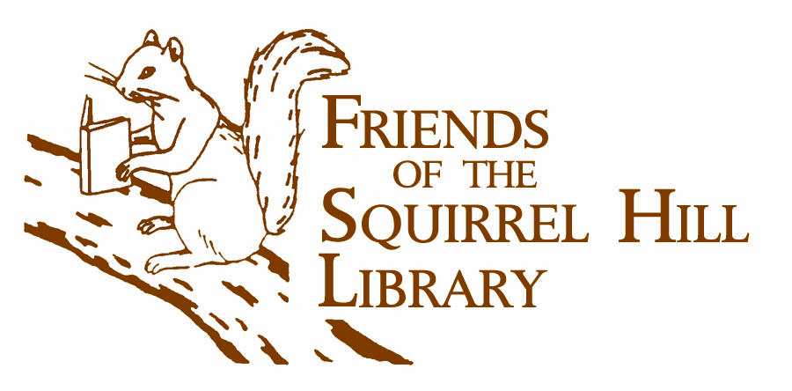
  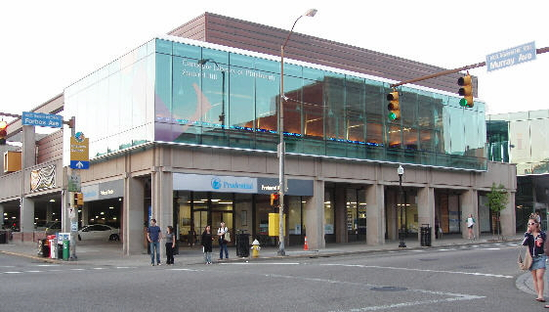
  DONATIONS WANTED
  Squirrel Hill Library
  5801 Forbes 412-422-9650
Friends Used Book Sales

April 13-19 - Spring Cleanup
during National Library Week

May 17-18 - Travel, Humor & Classics Mini Sale

June – no sale

for sales elsewhere, go to www.pittsburghusedbooks.com

Won’t You Be My Neighbor?
Inspired by Fred Rogers and Neighbor Days held throughout the city in March and April, the Squirrel Hill library is hosting "Won't you be my Neighbor Day" on Sunday, April 6th. See the enclosed flyer for details.

All good books are alike
in that they are truer
than if they had really happened
and after you are finished
reading one you will feel that
all that happened to you,
and then afterwards
it all belongs to you:
the good and the bad,
the ecstasy, the remorse, and sorrow, the people and places and
how the weather was.
Ernest Hemingway
1899-1961

Cut along the lines on the back for a reversible flyer.
If you can post a full-sized flyer at work, at school, etc., pick one up at the service desk at the library. They're available starting three weeks before each sale.
Library Knitting Group
Join us as we knit and explore the diverse collection of knitting and crocheting books the Library offers. The group is led by Linda Plummer from "Knit One."

Third Tuesday of every month
2:00 PM - 3:30 PM

Tuesday, April 15

Tuesday, May 20

Tuesday June 17

Registration is required. Call Knit One: 412-421-6666 or the Library: 412-422-9650.

Have you paid the Carnegie Library $30 or $50 for a Donor Card? Then you are the kind of patron – involved, supportive – we'd like to have in our Friends of the Library auxiliary. So we are waiving the fee for your first year's membership.

Just fill out the form on the next page.
(And yes, we are happy to accept a donation.)
Blood Pressure Check
Stay on top of your health by dropping in for a free monthly blood pressure reading by a nurse from the UPMC Living-At-Home Program.

2nd Tuesday of every month
11:00-12:00 AM

Upcoming Dates:

Tuesday, April 8

Tuesday, May 13

Tuesday, June 10

The Friends of the Library movement began in the 1920’s; there is no national group, but libraries all over the world have FOL groups.
The Friends of the Squirrel Hill Library
5801 Forbes Ave. Pittsburgh, PA 15217
www.clpgh.org/locations/squirrelhill
Friends@ pittsburghusedbooks.com
Library – 412-422-9650
open M-W 10-7, Th-S 10-5, Sun 1-5

7

April 2008 Among Friends Volume II, No. 2
Travel & Humor &  Classics  BOOK SALE  Relax and Enjoy the Sunshine  Sat May 17th 10 a.m. to 4:30 p.m.  Sun May 18th 1 p.m. to 4:30 p.m. | Make checks payable to:  Friends of the Squirrel Hill Library  and mail to:  Margie Spenser  5900 Douglas St  Pittsburgh, PA 15217  Check one box:  New Member Renewal  Check one box:  $3.00 $5.00 DONOR (free)  $10.00 $25.00 Other _____  Name:___________________________________  ^{(Last)} (First) (Initial)  Address: _________________________________  City/State: __________________Zip: __________  Phone(s): ___________________Date: _________  E-mail address: ____________________________  Please check all activities you can help with:  Periodic Book Sales Sorting Used Books  Adopt-a-Shelf Program Gardening  Library Advocacy Newsletter/ Mailings  (lobbying, writing letters)  COMMENTS_________________________  _________________________________  _________________________________  _________________________________
  Squirrel Hill Library
  5800 Forbes 412-422-9650800 Forbes 41212-422-9650

Is your Friends Membership up to date? Please check your mailing label/membership card, below. If the date is before 04/08, you need to renew. If you bring this page to one of our Used Book Sales, you'll get a free book with your renewal. Or mail us the form above.
your donation is tax deductible as a charitable contribution
CARNEGIE LIBRARY OF PITTSBURGH  SQUIRREL HILL  5801 Forbes Avenue  Pittsburgh, PA 15217 |  | NON-PROFIT ORG.  U.S. POSTAGE  PAID  Pittsburgh, PA  PERMIT No. 307
Adult Services: 412-422-9650  Children's Services: 412-422-9841  Fax: 412-422-5811  www.carnegielibrary.org/clp/sq  membership card | ADDRESS SERVICE REQUESTED  8
  
  EXPIRES:  Month YYYY | NAME  ADDRESS  CITY, ST


